Creative Writing Techniques: A Practical Worksheet
This worksheet is designed to help you practice some of the most essential techniques used in creative writing. Work through the sections at your own pace, and remember to have fun with it!
1. Show, Don't Tell
What it is: This is a core principle of good writing. Instead of simply stating a fact about a character or situation, you use action, thoughts, dialogue, and sensory details to reveal it to the reader.
Example:
- Telling: "She was sad."
- Showing: "Her shoulders slumped, and she stared at the floor, a single tear tracing a path down her cheek. The room's vibrant colors seemed to fade around her."
Exercise: Rewrite each of the "Telling" sentences below to "Show" the emotion or state.
- Telling: He was scared.
  - Showing: ____________________________________________________________________
- Telling: The old house was eerie.
  - Showing: ____________________________________________________________________
- Telling: She was very excited.
  - Showing: ____________________________________________________________________

2. Sensory Details
What it is: Bringing a scene to life by appealing to the reader's five senses. Engaging the senses of sight, sound, smell, taste, and touch makes the world of your story feel real and immersive.
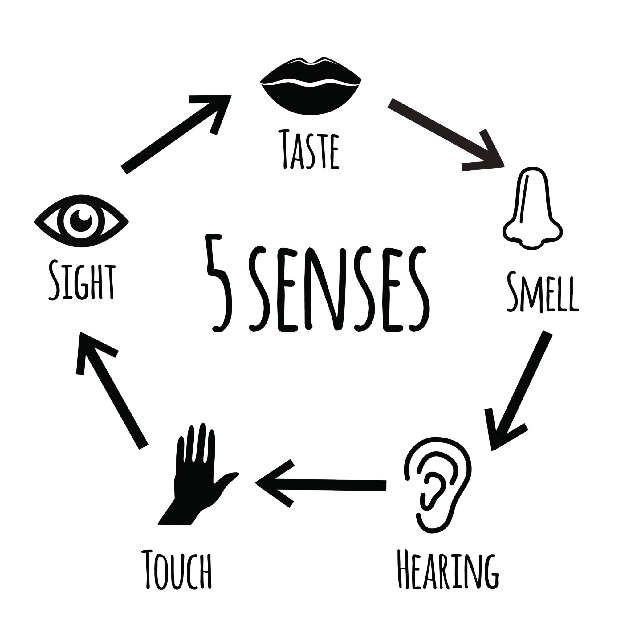
Licensed by Google
Exercise: Imagine you are walking through a busy marketplace. Describe the scene using at least one detail for each of the five senses.
- Sight: ____________________________________________________________________
- Sound: ____________________________________________________________________
- Smell: ____________________________________________________________________
- Taste: ____________________________________________________________________
- Touch: ____________________________________________________________________
3. Effective Dialogue
What it is: Dialogue should do more than just relay information. Good dialogue reveals character, moves the plot forward, and builds tension. It should sound natural, like real people talking.
Exercise: Write a short conversation (4-6 lines) between two characters. Use the dialogue to reveal something about their relationship or personalities without explicitly stating it.
- Prompt: Two friends meet after a long period of not speaking.
4. Figurative Language
What it is: Using creative comparisons to create vivid images in the reader's mind.
- Simile: A comparison using "like" or "as." (e.g., "The moon was as bright as a spotlight.")
- Metaphor: A direct comparison, stating that something is something else. (e.g., "The moon was a spotlight in the night sky.")
Exercise: Write one original simile and one original metaphor for each topic below.
- Topic: The Ocean
  - Simile: ____________________________________________________________________
  - Metaphor: ____________________________________________________________________
- Topic: A Crowded Room
  - Simile: ____________________________________________________________________
  - Metaphor: ____________________________________________________________________
5. Putting It All Together: A Mini Challenge
Write a single paragraph (4-5 sentences) that describes the start of a story. In this paragraph, try to incorporate:
- Showing, not telling
- At least two different sensory details
- One example of figurative language (simile or metaphor)

